**Conversation Guide: Digital Health Modernization Discovery Research**

**Bold text identify the moderator’s questions.**

*Text in italics are Jen’s observations and interpretations of the participant.*

[Text in brackets are interpretations in participants’ direct quote.]

**Background (5 minutes)**

To get started, I’d like to get a little background information about you, and your experience with the VA.

1. **Can you tell me a little bit about yourself?**

As to the veteran experience, I retired in 2014 and began enjoying the VA benefits immediately.

I went to work for the embassy in the Philippines immediately after retirement. They have one of the few VA hospitals outside of the US. I began doing the annual physicals with the VA hospital there for a few years before moving back to DC and resuming relationship at the VA hospital in DC.

It took a little while to get into the system in both Manilla and DC but it worked out well.

I have not visited since the pandemic. In 2020 I think the last one was in January or February.

Then for more background in respect to myself, I am still with the State Department and looking to retire in a year or two.

I am also a full-time student at George Washington University and in the third year of the doctoral program there.

**What’s the doctoral studies for:**

Public policy so I have at least another year and a half but making steady progress.

1. **When did you leave the military?**

2014. I was in the Army at one time but I spent most of my years in the Navy. I retired from the Navy.

**What motivated you to join:**

I joined after high school it was many years ago. *Participant laughs.* I enlisted in the Army National Guard then participated in a program between the National Guard Reserves and ROTC.

I was able to get my commission very young, barely 20 years old and I was still a full time college student. My commission was contingent on remaining a full-time student.

Shortly after I graduated went to work in Dallas for a Fortune 100 company. My first boss was a Navy reservist, and he talked me into changing from the Army Reserves to the Navy Reserves. That was in 1989.

From ’89-2014 I was in the Navy Reserves with a number of active duty tours.

Knowing I was going to retire in 2014 my last two years was in active duty in Hawaii.

**What do you do at the State Department:**

Foreign service officer. I joined in 2004 and have had a number of foreign service tours overseas. Also took multiple leaves of absence to be on active duty with the military. Back and forth between the military and state department until 2014.

1. **Do you have any family members who you claim as dependents?**

Yes, I have two adult children and a 4 year old as well as my lovely wife.

**3.a. Do your family members receive any benefits from the VA?** Not directly. Indirectly, yes. I have a disability and part of the disability stipend is that they are my dependents.

None of them receive direct benefits.

**You mentioned education was a benefit:**

It is a critical benefit because my doctoral program is funded by the VA largely. Going forward it won’t be. Briefly, the doctoral program is comprised with multiple components, one component is taking classes and I finish all my classes semester. But I am not done I have a way to go. However, you must take one credit until you graduate. I will not be looking to the VA to pay for that single credit. However, the program required 72 credits and the VA paid for all of them.

I couldn’t not have gone to George Washington University, a private school, and paid for the tuition without the VA’s help.

**For that one credit why not rely on the VA:**

When I retired I retired with 36 months of benefits and I think I have used 21 months of them. Before I retired I transferred all the benefits to my adult children and that had to be done while on active duty otherwise you loose the ability to do so.

The only way you can transfer is between the adult children or to myself. For example, I can’t transfer the benefits to my 4 year old.

So to answer the question I don’t want to take the around 15 months of benefits away from my adult children that they can use.

**For education specifically:**

In theory the either adult children could receive the benefits. I’m holding off to see, they are both in college but their current expenses are covered in other ways. So I am holding onto the benefit for their potential graduate school if they choose to go that way.

**Started VA benefits in 2014. Which benefits specifically**:

Visiting the hospital in Manila. I wasn’t sure if I got in before 2014, I move to Manila and this I had an appointment in December but it may have been early 2015 when I got in.

**You also mentioned a disability through the VA**:

Yes. Essentially I went through the screening process before I retired and within a year of retirement I was assigned a rating and I am not sure if that is what enables me to go to the VA hospital. Now that I think about it I am sure it does. I go to the VA mainly because of the disability, I think that’s why I am able to go. I think, I don’t know.

**Applied for disability prior to retiring:**

The screening process is long and Hawaii is not an uncommon place to retire from so it’s a common experience among soon to be retirees go through the screen process to see how the decades of toll made have added up on your body. *Participant is indicating location and population - in this case a retiree-heavy one - made a difference in their knowledge of benefits.*

1. **Do you manage any of your VA benefits online?**

Not as actively as I would like.

I do go onto Ebenefits a couple times a year.

I do know that even as for back as 2015 when I first had my VA healthcare interaction it was explained and I was informed that I could communicate with my provider through My HealtheVet.

*Participant doesn’t use the site but still knows it by name as My HealtheVet.*

For prescriptions there is an online tool to communicate with the provider. I think I had to logon then as early as 2015.

That potentially helpful tool I don’t take advantage of. I think it’s My HealtheVet. If you ask me to log on I wouldn’t know how to.

I know it is a tremendous opportunity to take advantage of.

**As far as education:**

The only thing is, remember earlier I noted that before I retired I transferred education benefits to my adult children. So I claw them back prior to the semester to pay for my own tuition. So just before every semester I take benefits back from them, and I do that online. The means I do that is simply by reducing their number of months. I forget my initial distribution, I assume each got 18, then each semester I take maybe 2 months back. Reducing their numbers the benefits come back to me which is critical in paying for tuition.

1. **You have private health insurance, through work:**

Yes that is right

**Can tell me about the experience of having both VA and employer health insurance:**

The VA of course requires that disclosure.

When I do visit the VA hospital they bill Blue Cross Blue Shield, who is my provider that I pay for through my employer. Of course there is a co-pay with the employer. I am happy the VA can get money from Blue Cross Blue Shield for the wonderful services they have been able to provide me.

1. **Do you receive care outside for of the VA for your health needs:**

I have been very satisfied with the VA in DC. As you can imagine I think it is one of the larger one in the system so they have specialists. Since I moved back from Manila all of my health needs has been meet and satisfied from the VA hospital. Every single one.

1. **For your family, are they covered under your work:**

Yes. They are not eligible to go for service at the VA hospital. That is my understanding anyway.

1. **Do you use online tools for private care:**

Yes, Blue Cross Blue Shield, specifically the Federal Employees Program (FEP). They have something referred to as MyBlue.

I don’t frequently go on it but I can access my explanation of benefits and of course with 5 of us on there I make sure that explanations of benefits are monitored and everything is there.

I think I go on MyBlue quarterly, not more then 3-4 times a year.

There was an incentive program with FEP to do an annual health questionnaire for $50.

Then option to participant in online goals, it is the honor system. You should report if you want an exercise goal or diet goal and they will pay you three $40 goals, put to $120. Between my wife and I we could earn $170 each that can be applied toward healthcare costs like copays. We have been good at maximizing that benefits over the years and it keeps us engaged with the online MyBlue over the time.

1. **Do you use any mobile apps to manage your health?**

I have a Fitbit. I know there’s an app but I use it on my laptop because it interferes with the laptop app.

Outside of that, no.

I have never explored VA health benefit apps for phones but I would be interested in pursuing that.

**What need would you look for:**

To be honest, one of my disabilities is sleep apnea. If I could improve my management of that. So if there is a way to improve the management of sleep apnea through an online app that would be something I would be interested in.

**Mental model of health at the VA (20 minutes)**

Now I’d like to hear about your experience transitioning from the military to the VA. **(10 minutes)**

1. **How did you learn about the health care available to you through the VA, and what was the process of applying for and accessing those benefits?**

I’m sure it was essentially through colleagues. I was on an advisory team for the Pacific Command, so it was a four-star command, and consequently was staffed with fairly seasons sailors, marines, soldiers, it was a joint command. So I am sure it was word of mouth from other. I mean every month I was there for my two years was a retirement ceremony, so just a lot of people going through the retirement process. It clearly was a conversation topic.

I was advised I forget how many months before retirement to start the process. I did so just as many others were going through same process.

So initially it was word of mouth but I did use Disabled Veterans of America (DAV) as sort of my mentor through the actual application process.

1. **How would you explain a “disability rating” to a new Veteran**

That’s your first hard question.

If I had to sum it up in one word I would use confusing.

Others, not my original word, others others note there is VA math. I didn’t know what it meant until I looked at my VA letter. I understand very generally that other percentages are fractionalized.

My initial comment would be that the rating system has layers of complexity it’s not necessarily super straight forward.

1. **What would you say your disability rating impacts**:

If we wanted to partition those with a rating, there are those with a 100 percent rating and those that don’t. My understanding is that there is a huge difference between the two and there should be.

My understanding the benefits are helpful but should something occur that I am no longer in this reality like I pass away my benefit is vaporized. Anyone under 90 percent is similar, and with respect to my dependent I need remedies in place for them.

Whereas those at 100 percent their dependents are still taken care of to some extent.

In my mind whether my rating is 20 percent or 99 percent, even though I am very very grateful, we still need a backup and I suspect those with the 100 percent feel a little more relieved that their family is taken care of.

**Your understanding is 100 percent you receive survivor benefits but below doesn’t:**

Yes. That is my understanding, I again don’t have the highest level potential understanding.

1. **In your mind, is there a relationship between “disability” and “health care”?**

That is my understandings, I think it may have been in the information that was sent with my rating.

As I recall took about 9 months from when my application was turned in until I got the rating letter. I am sure it was in the initial packet that it was something.

I went through this in Hawaii and they have a wonderful VA hospital that is part of the Army hospital. So I have gone there on a number of occasion and they gave me an id, my veterans id. It reflects my disability status and that card is the first thing asked for at every appointment and I use it to scan and check in.

I assume by talking to other veterans who don’t have that card, and I have the card because I have a disability.

**The disability rating provides you this ID card which provides you access to the hospital:**

Yeah. That is my understanding. Here is my ID and this was given to e in Hawaii. *Participant shows actual id card.* I didn’t ask for it but I am happy to have received it, I’ve kept it in my wallet for the last 5 years, and it has come in mighty handy.

**When you say you didn’t ask for it, what did you think you would receive once the paperwork was done:**

I figured I would have a retired ID. I assumed my DOD ID would be sufficient. I didn’t think the VA would have it’s own ID system, makes sense of course. But it is not something I was exposed to before.

**Is there a relationship between the disability and healthcare at the VA**:

I think in my case yes because again it is because of my disability that I am able to get care through the VA hospital system.

1. **When it comes to your health care, what is the most important thing you need from the VA?**

I do have a number of specific disabilities but I think it would just be overall health.

At my current age I think it is unconventional to have a 4 year old so I look after my overall health.

One thing that in ingrained in most service member there is an annual required physical and it is fairly comprehensive. So the navy did that on our birth month. I retired in September 2014 and I was going back and fourth between Hawaii and Manila. It was important to me try to get in the VA in December to keep the annual birth month appointment every December.

It was going to be with the VA and I was able to do that, I didn’t do it this month because of COVID. I went last December for my physical.

My thinking would be every December thereafter at a minimum. But generally at the VA I am in the green clinic, my doctor I try to see her every December then she refers me to a specialist for my disability.

The overall health is that annual checkup. I could do that from a local provider but I like having that the continuity from the VA and DOD. The VA has my entire health record from the military so all VA’s can see that whereas a private doctor would not have that long medical record.

Now I’d like to ask you how you manage information and tasks related to your health care. For each one, talk me through the steps you’d take. If there is something that you go online to complete, I may ask you to share your screen so I can see what you would do. **(10 minutes)**

**Tasks** Moderator should prompt about device usage if participant mentions digital tools or resources.

* **How would you reach out to your VA care team if you had a question?**

Again I know of the My HealtheVet system but I have never used it.

I would call the 800 number for the DC hospital then it’s not a 800 number it’s a 202 number and I would say my doctor and green clinic.

I would get on the phone and do it. It is as simple of that.

I don’t know if my doctor is there since I haven’t been there in a year but I assume she is.

**When calling can you schedule it right then and there or is it a multi-step process:**

It might be multistep for them but for me within the scope of that one call I can get something scheduled.

* **Why not use online side of things:**

Besides laziness I don’t have a good answer.

Like all of us we have busy schedules. With My HealtheVet I know I could do it at 4am.

But at the same time I am driving during the day and can get on the phone and make a call somewhat easily. Yes there are hold times with a phone call but within 15 minutes in the call I can get it scheduled as well.   
Again with My HealtheVet could probably do that as well.

* **How would you refill a prescription you have with the VA?**

I think I have to see the doctor.

In rare circumstances that is waived but I think I have to see her anyway before that occurs.

With sleep apnea I see the sleep department and that doesn’t not require me to go to through primary clinic. They are great. I talked to my sleep doctor in the past few months, I made appointments prior to COVID to look at issues but I choose to cancel that until after COVID. But he called unsolicited to check in and that was comforting.

**Can I assume you’re not taking a daily medication that you need refills:**

True, I am fortunate. I don’t recall the last time I took medication. No, I am not on a regular prescription.

* **How would you go about checking the date of an upcoming medical exam you have for a disability claim?**

Again there’s a text message notification option, and an email option and with respect to the DC hospital I would get notified. I would go in for my appointment and then be referred to a specialist. I walk over to that wing of the hospital, check in, and get myself scheduled face to face after they were notified I was coming.

I would make an appointment, then three things would happen. I would get a post card in the mail, sometimes more than one postcard in the ail, I get a text and email. Between the three I have never ignored them. I probably went to 90 percent of my appointments for the 10 percent cancelled I was able to call ahead to the specific department. They are the individual that requires the call to reschedule.

Maybe it could have been done on My HealtheVet. *Participant laughs.*

* **Is that similar process you would use for primary care:**

Yes. The difference would be to see primary care I get on the phone to schedule the appointment so I know it is done. They look and tell me when the soonest available is.

I think that’s where the online tool would be interesting because getting the appointment scheduled it’s an iterative dialog process, where I am looking at my calendar and they are looking at their schedule.

It’s never like I want 4pm tomorrow. That will never work and then the dialog has been helpful to find out something that mutually would work.

* **Do you remember how (or if) you opted in to get notified email/text:**

I would guess it was directly done at the hospital.

Or it may have been options I selected in an online process but I doubt it.

With respect to overall compensation issues I go to ebenefits but for healthcare issues I cannot recall actively using the online systems. So it must have been through the hospital directly.

When I am asked I am open to any means of communication possible. Obviously, they don’t want appointments missed.

* **Do you pay any co-pays for your VA healthcare:**

I don’t think so.

When I see the EOBs they tell me they sent money to the VA. Sometimes they [EOBS] reflect that I owe the typical $30 on my plan.

I think I see on the EOBs that I owe the VA the $30 copay that however I am sure I have never paid the VA.

I never get a bill from the VA. Maybe one day I will get a big one someday with it all on there. *Participant laughs.*

* **You’re not seeing bill for copay - are you getting anything from the VA about how it’s breakdown:**

No, but I remember getting the appointment card. I don’t recall any after appointment correspondence or documentation. Medical supplies yes, prescription in the mail, yes. With respect to an after action report feedback from the insurance no.

On the education side, yes. On the education side a lot of correspondence. Pre and post payment to the University, but not on the health side.

* **What are you seeing on the education side:**

There is an office built into the George Washington University experience. It is called the Military and Veterans Affairs office, the MVA office. It has a half dozen professionals and there’s a certifying officer. So there are formal communications between their office and the VA. My, for lack of a better work, VA office is in Buffalo, NY district so all correspondence is from that office.

They will inform me that credits confirmed and the benefits allowed, here’s how many days you are eligible for and I am updated to the day. I look at each day as critical and that is what the correspondence is about.

Each semester I get at least three letters minimum. What is common, I have been told it is, the certifying official does not communicate the specifics of my registration initially. That they put in something that generates the housing allowance. Because I get a housing allowance. So something is generated and communicated to the VA that I will be a full-time student but the specific number of credits is not locked in. They wait until I am done my drops and adds of courses before the University send the VA the bill for tuition. I get letters on both occasions. So I get communication beforehand; yes you’re a full-time student, here’s your housing allowance and here’s your preliminary book allowance. Then I get a letter stating it’s not preliminary anymore. A third letter comes letting me know the amount they have paid the university.

* **Sounds like the VA communicated back to you what you communicate to the University**:

Yes, but to be more specific I am not directly communicating with that office. I do on occasion for specific purposes, but in general that office does have access to my school records. So all I am doing is the same thing anyone else would be doing. I am just registering for my classes. I have to request the office to certify me. It is part of the University’s registration system that I am requesting VA certification, that then it allows them [VA] to talk to the MVA office and it is done internally through the school.

* **Outside those three mailed letters do you get anything online or via email:**

From the education perspective specifically the answer is no. Again pre-semester I have to go in to take the benefits back from my adult children, but that’s because I arranged it that way to preserve their benefits. I only hold onto it for their graduate studies. My son probably won’t use them. I have until he’s 26 to transfer to his sister who probably will. I am done with mine and I don’t want the benefits to go to waste.

* **Let me share my screen and get your feedback on these websites**:

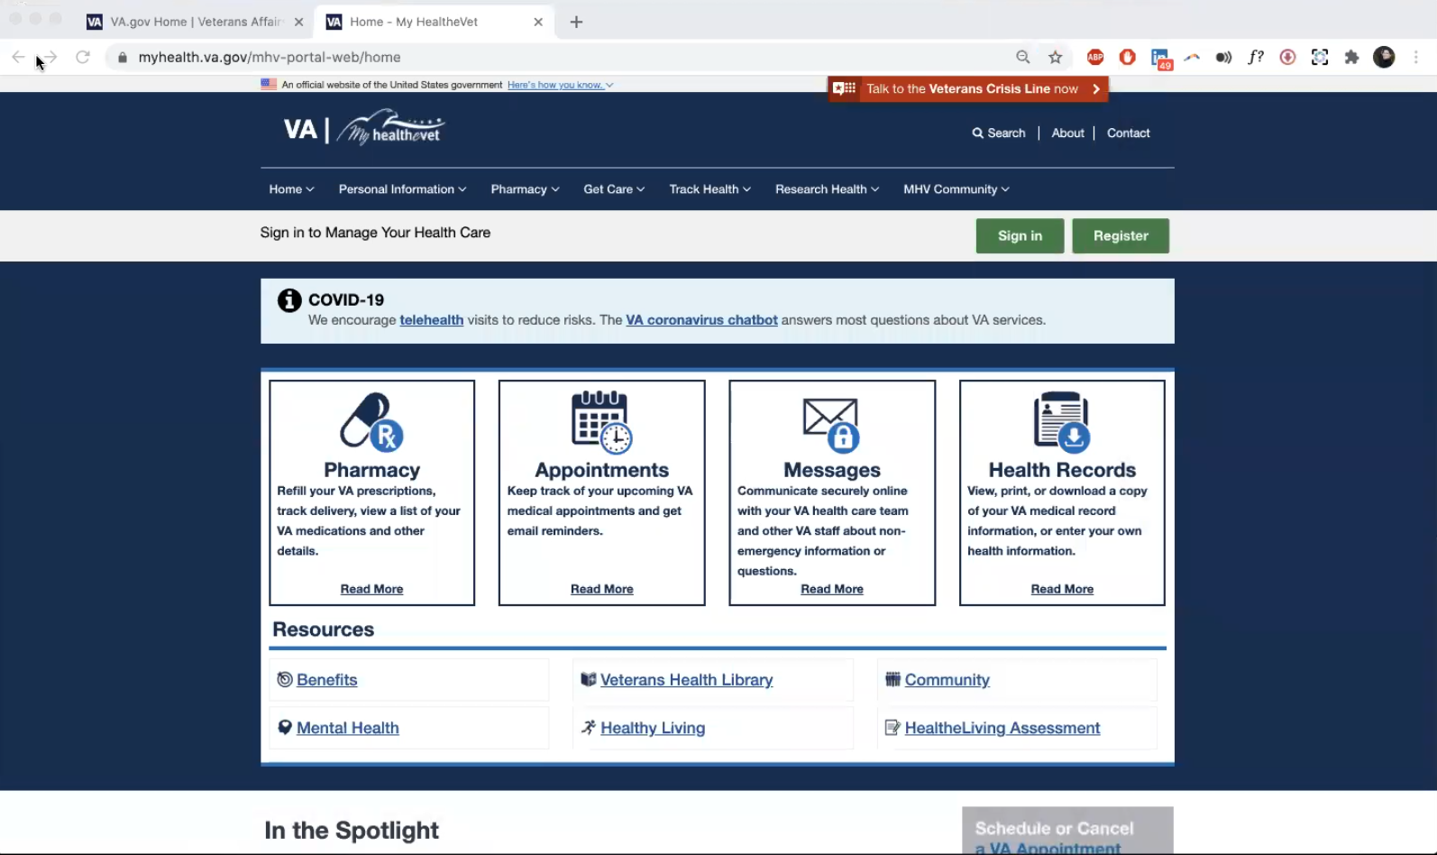

*Moderator shares screen showing My HealtheVet website.*

My HealtheVet. Yes, I was exposed to this in 2014.

I will say this is not stressed when I go to the VA in Washington DC. I think if it was, like if they made me login to this each time I went in to the hospital in DC. I would initially be irritated but I think the bigger picture is that it would be helpful. If the hospital made me log in every time.

In Manila they asked if I wanted to be exposed to this and I said sure. They were sort of much more progressive in pushing this site. But DC is not.

But, yes I have seen this screen.

* **Va.gov**:

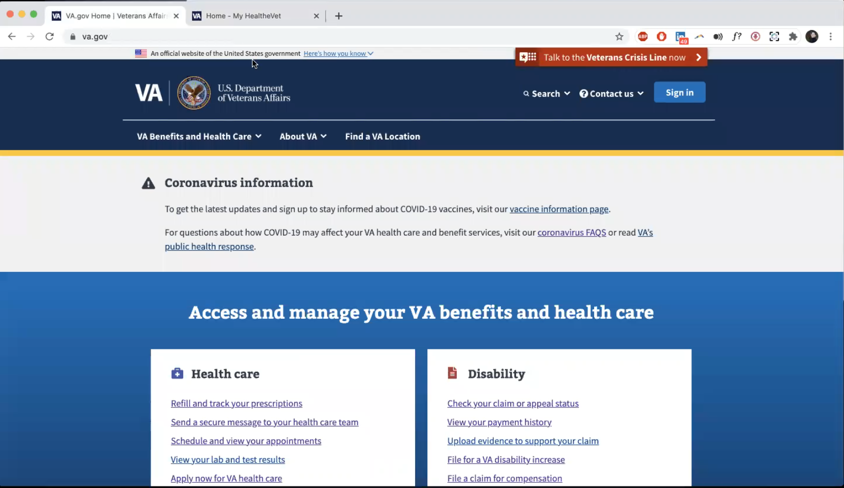

*Moderator shares screen showing [VA.gov](http://VA.gov) website.*

I have definitely been here. Wait a second.

That’s the more general, yeah, that’s like ebenefits right.

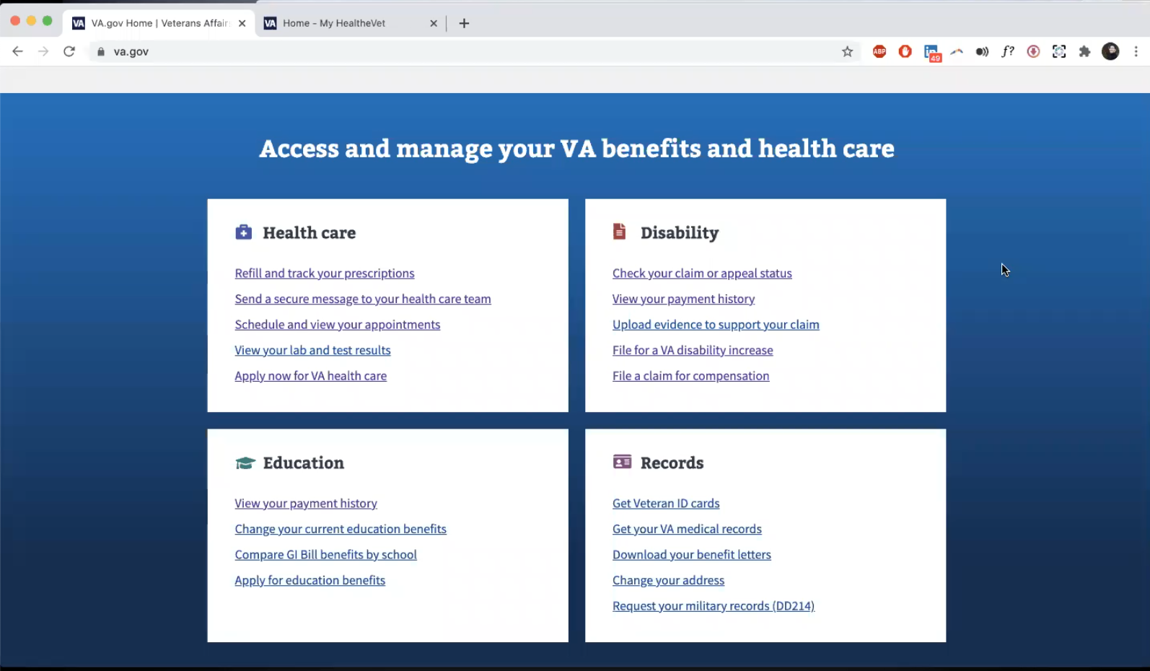

*Moderator scrolls down screen showing [VA.gov](http://VA.gov) website.*

Yes, this is the screen is what I am the most familiar with.

So for example the view the payment history I have done on occasion.

* **So this page looks familiar?**

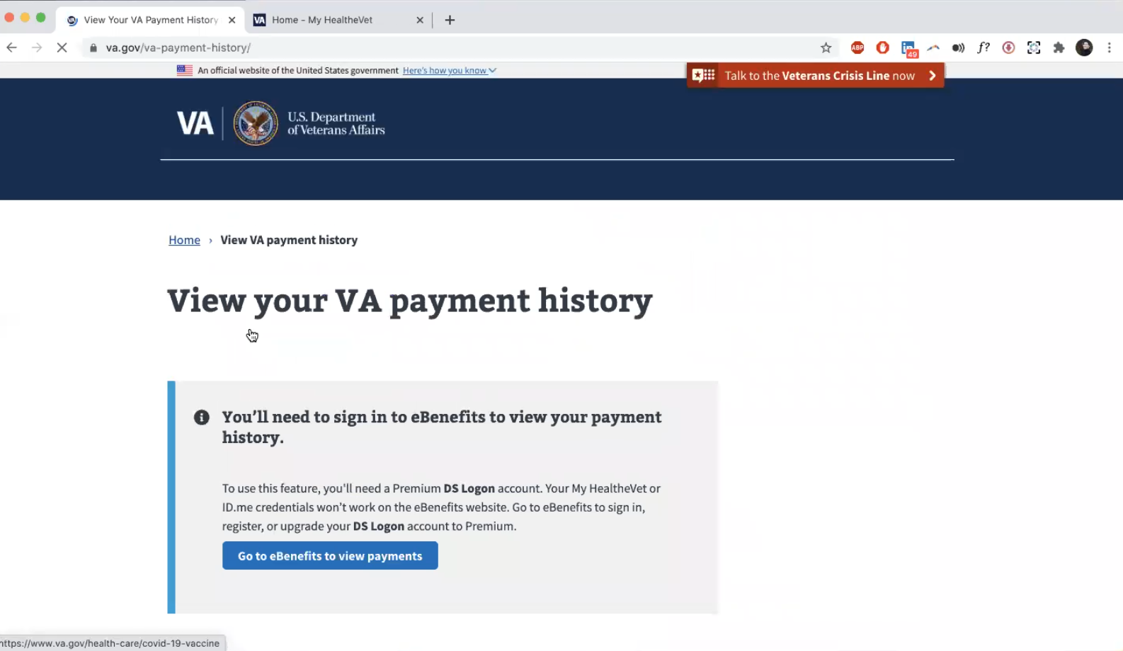

*Moderator clicks on “View your payment history” under “Education” and shows page to participant.*

Yes. Absolutely. I would say that at least 3 times a year I take a look at that to make sure things are in order.

* **For education credits:**

I think it is more than that. For example, with the adult children as they start to age out it effect my disability payment as well. 4 years ago I added my daughter. And that effects the payment. The increase and decrease of eligible dependents.

**Thank you and closing (2 minutes)**

**Feedback**:

No. I suspect. What would be the biggest motivating factor if you are trying to sell me the online tools. What am I missing out on?

*Moderator shares screen and explains what we’ve heard from other Veterans is the Pharmacy/ Appointments/ Messages/ Health Records blocks on My HealtheVet home page.*

This is helpful and motivating and I will make an effort to log in.